|  |  |
| --- | --- |
| Practices]  **Module Code**  IT43001FP  **Duration**  3 hours | **Title:** Software Development Lifecycle Methods    **Objective(s):**    In this lab, students will learn to   * identify the various phases of SDLC and * choose suitable software development method for the given project     **Tools, Equipment and Materials:**     1. [Hardware: Personal Computer with Internet access] 2. [Software: Text Editing Software]     **Instructions:**    **Lab 1: Compare software development lifecycle to building a house and identify the activities during different phases** |

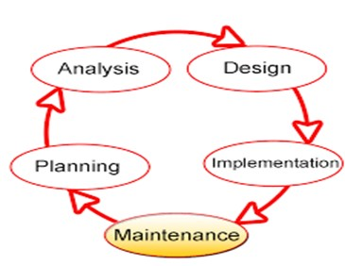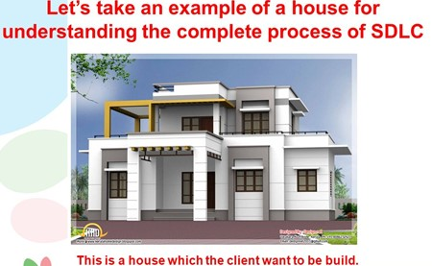

**Students to work in group of 4 to research and discuss about different phases of SDLC.**

**Every group need to do a quick sharing of their work.**

|  |  |
| --- | --- |
| **SDLC Phases** | **Requirement Development Activities (Building a House)** |
| Analysis Phase   * Business Requirements (Surveys, Interviews, Use Cases) * Functional Requirements * Non-Functional Requirements | Analysis Phase   * Occupants > Rooms, sizes of rooms * Type of building * Style * Engineering Requirements |
| Design Phase   * UI UX design * System design * Database design * Software specs | Design Phase   * House plan/Blueprint * Parts/Items required * Engineering Plans * Schedules/Timeline |

|  |  |
| --- | --- |
| Implementation/Development  Phase   * Code/develop the software | Implementation/Development  Phase   * Build the house according to the plans |
| Testing  Phase   * Unit Testing * Integration Testing * System Testing * Acceptance Testing | Testing Phase   * Electrical test * Water system test / Plumbing test * Heat system / Aircon test * Appliances test (oven, water heater) |
| Documentation  Phase   * Technical documents * User Guide (documents) | Documentation Phase   * SLA, ministries approval documents * Buyer/seller * Contract documents * Appliances instructions documents |
| Implementation/Execution Phase   * Launch the system/app * Hand over the * Handover the system to stakeholder * Training | Implementation/Execution Phase   * Launch the project * Sign the sales contract * Hand over documentation and keys to the buyers |
| Maintenance  Phase   * Monitor the system * Bug fixing etc | Maintenance Phase   * Monitor the property (HDB or MCST) * Fix all problems * Fix wear & tear |

Practices]

**Module Code**

IT43001FP

**Duration**

3 hours

# Lab 2: Research on suitable Software Development Methods for the given project scenario

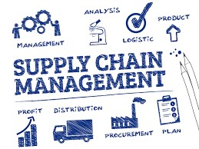

**Logistics & Supplychain**

Blaze Technologies is one of the leading web design company in Asia. They create custom built **website development** solutions that help brands in translating their vision into compelling digital experiences. Recently, they delivered a fully integrated IT platform for a leading logistics and supply chain management solutions that has a strong foothold across the globe.

**Project**

Web Application

**Technologies**

ASP.NET (3.5 Framework)

|  |  |
| --- | --- |
| Practices]  **Module Code**  IT43001FP  **Duration**  3 hours | **Location**  UK    **Challenges**    Client has a global infrastructure of resources to provide core intermodal services of shipping, air cargo and road distribution complemented by logistics, supply chain management, duty management, cool chain and courier services. They play a successful role in the internet market, but still they wanted to improve their logistics and supply chain management services with an integrated IT platform to carry out their services swiftly.    Suggest the best SDLC method to improve their logistics and supply chain management services with an integrated IT platform to carry out their services swiftly.    **Students to work in group of 4 to research and compare Agile and DevOps software development models for the given project.** |

|  |  |  |
| --- | --- | --- |
|  | Agile | DevOps |
| Benefits | For first time beginners. Agile is easy to manage while exploring.  Agile enables concurrent development and delivery within an overall context. | In recommends you a more stable and open operation enviroment.  It gives you the opportunity to use up the time to innovate other than fixing bugs. |
| Drawbacks | Agile model depends heavily on customer interaction. Making a mistake will cause the team to give them the wrong idea  Agile lacks predictability. | In order to develop with DevOps, you need a lot of money to pay which is too expensive.  DevOps professionals or expert’s developers can’t be available all the time. |

- End -